

DISSERTATION PROGRESS BOOK

Name of the students : 1. Ms. Neha Anil Rathi
2. Mr. Jayant Junankar
3. Ms. Kshitija Dahiwale
4. Ms. Pragati Kapsikar
5. Mr. Sarvesh Mandale

Course:- Computer Science Engineering

Year of Admission: 2016

Name of the Internal Guide: Prof. Chetan Dhamande

Dissertation Title: Restaurant Bot

Area of Work: - Developing a realtime chatbot and the realtime website

Department Of Computer Science and Engineering
Jawaharlal Darda Institute of Engineering & Technology,
Yavatmal, (M.S), India-445001
Session 2019-2020

GUIDELINES

1. Handle the progress book carefully.

2. Student must enter the correct information in the progress book.

3. All the entries in the progress book should be verified by the concerned guide. 4. Student must report to their respective guide as per the time table.
5. Activity planned should be completed as per the schedule.

- Submit soft & hard copies of Synopsis, Seminar & Dissertation reports as per University & College guidelines.
- This book, along with soft & hard copies of publications must be submitted to Guide / Coordinator / before final submission of dissertation.

2

INDEX
.
1. Undertaking by the student
2. Sponsorship
3. Dissertation schedule
4. Abstract
5. Work details
6. Monthly planning sheet (June to May)
7. Progress Report
8. Pre-submission demonstration application
9. Summary of pre-submission presentation & demonstration
10. Seminar & dissertation report final
11. Specimen for project stage I
12. Details of meeting between Internal Guide and CoGuide
13. Attendance
14. Participation in conferences / workshops
15. Publications an presentations Attendance

UNDERTAKING BY THE STUDENT

We
1] Ms. Neha Anil Rathi -17
2] Mr. Jayant Junankar - 50
3] Ms. Kshitija Dahiwale - 12
4] Ms. Pragati Kapsikar -22
5] Mr. Sarvesh Mandale -68

Student B.E (Computer Science and Engg) is hereby assured that we will follow the rules and regulation formulated by JDIET Yavatmal Amravati University and College regarding dissertations work.
The dissertation work entitled-

“The Restaurant Bot”

Will be fully designed / developed by us and assure, this work will be assigned work.

[ ]

Name & Signature of the Students

Date:

Place: Yavatmal

SPONSORSHIP (If Applicable)

Paste Visiting Card Here

Name of Sponsor: _______________________________________________________________________________

Adress:____________________________________________________________________________________________

Tel. No.:__________________________ Mobile No.:____________________________________________

Fax: ______________________________ Website:_______________________________________________

Person to Contact / Guide: 1.________________________________

Mobile No.:_____________________ Email ID:____________________________________________

2.________________________________

Mobile No.:_____________________ Email ID: ___________________________________________


PERT CHART OF THE DISSERTATION WORK (To be prepared by the student)

Dissertation (Project) Schedule

Semester VIII (prepare this sheet for complete subgroup)

Sr. No. | Activity Schedule | Date
1. | Searching for the various project development ideas in hardware and software domains | 2/12/2019
2. | Selecting software as our Main domain and looking for various trending project ideas | 9/12/2019
3. | Deciding chatbot as our project and looking for various applications of chatbot and confirming it to the Restaurant Bot | 16/12/2019
4. | Understanding the Requirements of the project for Restaurant bot | 23/12/2019
5. | Recognizing multiple viewpoints, considering different usage scenarios, working for collaborations of requirements | 30/12/2019
6, | Analyzing the collected Requirements and defining work flow for the project by dividing project into two different modules as The Restaurant Bot application for users and Restaurant Bot Website for Restaurant Owners with admin rights | 7/01/2020
7. | Searching for various languages and tools available for developing apps and websites | 10/01/2020
8. | Designing various UML diagrams for different modules in the project | 14/01/2020
9. | Designing logo for project using Adobe Photoshop | 17/01/2020
10. | Making wireframes for the projects app and website | 28/01/2020
11. | Converting wireframes into protypes and screen design for user experience using Adobe XD | 4/02/2020
12. | Making prototypes interactable by adding timings, settings and other jump flows | 7/02/2020
13. | Installing Android studio, Dart SDK, flutter SDK, and Visual studio code. | 11/02/2020
14. | Getting our hands dirty in dart language | 18/02/2020
15. | Getting our hands dirty in flutter and understanding widgets | 25/02/2020
16. | Designing the signup and login page of the bot | 8/03/2020

PERT CHART OF THE DISSERTATION WORK (To be prepared by the student)

Dissertation(Project) Schedule

Semester VIII(prepare this sheet for complete subgroup)

Sr. No. | Activity Schedule | Date
17. | Connecting bot with firebase realtime database and authenticating the users name and phone number by sending the OTP | 11/03/2020
18. | Verification of the OTP and redirecting user to the Scan page. At the same time storing name and related info in our database | 15/03/2020
19. | Asking for Camera Permission from the user and opening the scanner to scan the QR code in the Restaurant | 18/03/2020
20. | Decoding scanner code and welcoming the user to the respective Restaurant | 25/03/2020
21. | Creating interaction between the chatbot and user in interface format (designing frontend) | 1/04/2020
22 | Designing Dialogflow persona with different Natural language processing conversions | 8/04/2020
23. | Developing the bot by using intents , entities and saving extracted data in firebase | 12/04/2020
24. | Adding advance functionality to bot using followup intents, slot filling and using different contexts and deploying it for testing | 15/04/2020
25. | Connecting the bot with flutter app using flutter-dialogflow library and finally making it to do real-time chat | 19/04/2020
26. | Making Website using HTML,CSS, Javascript and Connecting it with firebase realtime database | 22/04/2020
27. | Documentation | 25/04/2020
28. | Realtime testing with Android app | 1/05/2020
29. | Realtime testing with ios app | 6/05/2020
30. | Checking for bugs if any | 9/05/2020

ABSTRACT

Daily life turning digital is fascinating all the way. Things are getting better in their level of accessibility on a technical mode. And here it is to present one bit of technicality on a learners view.
Chat bots! Running the digital market outside successfully and smoothly. A chat bot is a computer program designed to simulate conversation with human users, especially over the world wide web. In reality, the purpose of a chat bot is to support and scale business teams in their relations with customers and redefine the existing guest experience. By doing this a restaurant business can save loads of money which is why many business owners are adopting this technology and replacing the conventional human live chat agents.
Till now restaurants have been using apps for all the work which are not user friendly. But with increase in use of chat bot many restaurants are thinking of using chat bot app instead off traditional apps. Restaurant chat bots are the modern-day equivalent to a concierge, and with one of the latest bots, your customers no longer need to make a call to reserve a table, wait for staff to attend to them or wait in line for tables to free up. Restaurants don’t need to have a exclusive service executive for the customers either.
Restaurant bot is a chat bot that will be used for faster interaction with the customers. For this purpose, a mobile app will be used. The mobile app will contain the chat bot. Using the restaurant bot will be very beneficial for restaurants as it will save the time of waiters. Also, it is much more user-friendly than other apps. Customer will order the dishes using the bot. For all the chat it will use NLP and separate the meaningful information from it. The final order item will go to the admin. Chat bots in restaurants need to be perfectly synchronized with the marketing and other customer oriented efforts. Bots can parallely serve as an intelligence gathering tool which assists a restaurant in understanding their customers
WORK DETAILS

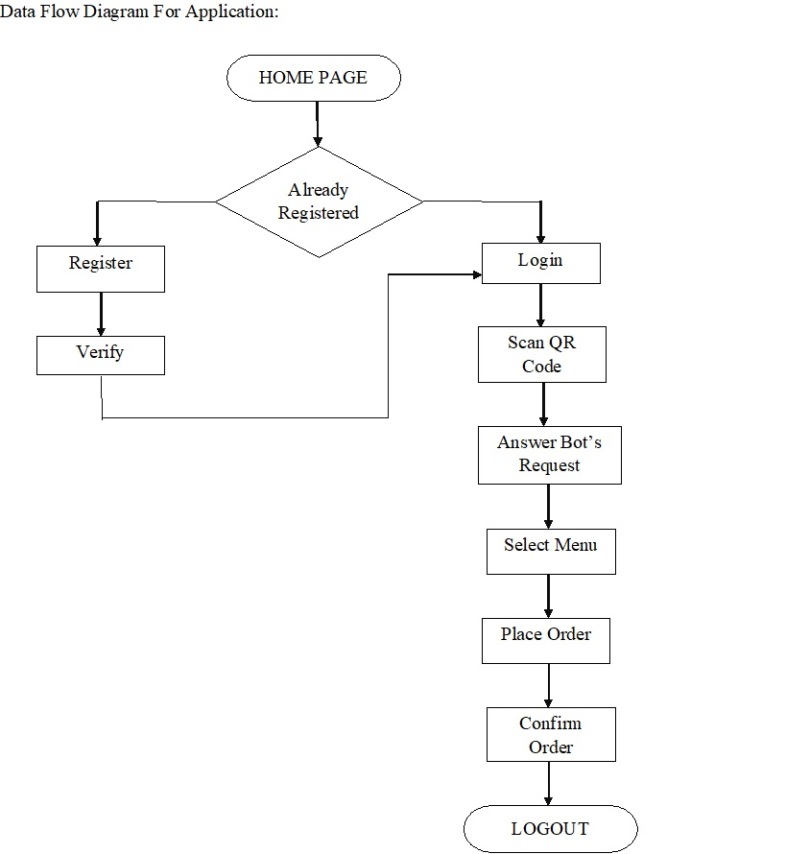

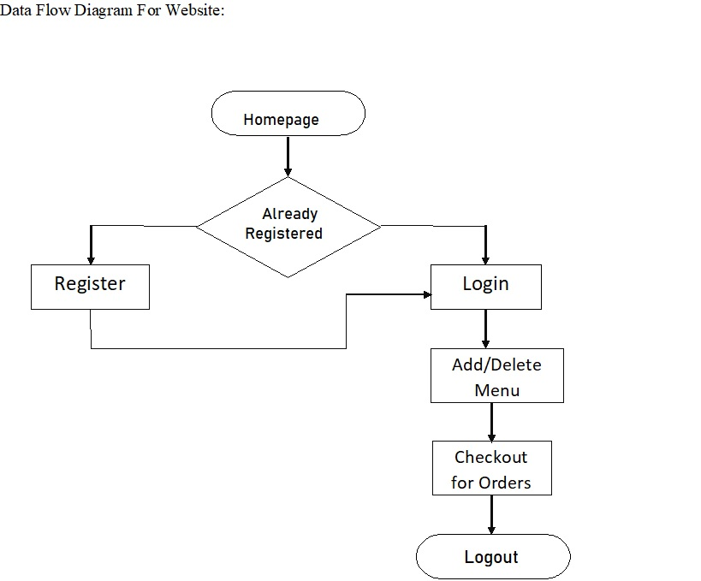

Required H/W, S/W platforms: -
- Adobe XD
- Adobe Photoshop
- Android Studio Code
- Visual Studio Code
- Dart Software Development Kit
- Google Flutter Software development Kit
- Google Firebase
- Google Dialogflow
- Android Emulator/ Android Smartphone (for testing and output of app)
- IOS Emulator/ iPhone (for testing and output of app)
- Browser (for testing and browsing website)

Performance measures & testing procedure:

Applied Test Cases

Application Testing:

- Are customers getting OTP within 30sec of registration?
- Are customers able to verify themselves?
- Are already registered customers able to log in themselves?
- Are customers getting scanning result properly?
- Are customers able to select the menus according to their needs?
- Is chatbot identifying customer needs?
- Are placed orders getting to the customers from the hotel?
- Is there proper synchronization between chatbot and the website?

Website Testing:

- Is admin able to register the restaurant and fill details properly?
- Are admins able to log in?
- Are admins getting real time entries from the customers?
- Are admins able to add new dishes in realtime according to availability?
- Are admins able to delete dishes in realtime according to availability?

Referred books / Paper:

[1]. Bai Li, Nanyi Jiang, Joey Sham, Henry Shi and Hussein Fazal “Real World Conversational AI for Hotel Bookings”

[2]. G. Mesnil, Y. Dauphin, K. Yao, Y. Bengio, L. Deng, D. Hakkani-Tur, X. He, L. Heck, G. Tur, D. Yu et al., “Using recurrent neural networks for slot filling in spoken language understanding,” IEEE/ACM Transactions on Audio, Speech, and Language Processing, vol. 23, no. 3, pp. 530–539, 2015.

[3]. M. Peters, M. Neumann, M. Iyyer, M. Gardner, C. Clark, K. Lee, and L. Zettlemoyer, “Deep contextualized word representations,” in Proceedings of the 2018 Conference of the North American Chapter of the Association for Computational Linguistics: Human Language Technologies, Volume 1 (Long Papers), vol. 1, 2018, pp. 2227–2237.

[4]. E. F. T. K. Sang and F. De Meulder, “Introduction to the CoNLL- 2003 shared task: Language-independent named entity recognition,” in Proceedings of the Seventh Conference on Natural Language Learning at HLT-NAACL 2003, 2003.

[5]. J. Pennington, R. Socher, and C. Manning, “GloVe: Global vectors for word representation,” in Proceedings of the 2014 conference on empirical methods in natural language processing (EMNLP), 2014, pp.1532–1543.

[6]. A. Severyn and A. Moschitti, “Learning to rank short text pairs with convolutional deep neural networks,” in Proceedings of the 38th international ACM SIGIR conference on research and development in information retrieval. ACM, 2015, pp. 373–382.

____

MONTHLY PLANNING SHEET (For Project)

Month: December

Sr. | Activities planned with | Remarks | Signature | Signature
No. | duration |  | of the | Int. / Ext.
 |  |  | Student | Guide
1) | Searching for the various project development ideas in hardware and software domains
2) | Selecting software as our Main domain and looking for various trending project ideas
3) | Deciding chatbot as our project and looking for various applications of chatbot and confirming it to the Restaurant Bot
4) | Understanding the Requirements of the project for Restaurant bot
5) | Recognizing multiple viewpoints, considering different usage scenarios, working for collaborations of requirements

MONTHLY PLANNING SHEET (For Project)

Month: January

Sr. | Activities planned with | Remarks | Signature | Signature
No. | Duration |  | of the | Int. / Ext.
 |  |  | Student | Guide
1) | Analyzing the collected Requirements and defining work flow for the project by dividing project into two different modules as The Restaurant Bot application for users and Restaurant Bot Website for Restaurant Owners with admin rights
2) | Searching for various languages and tools available for developing apps and websites
3) | Designing various UML diagrams for different modules in the project
4) | Designing logo for project using Adobe Photoshop
5) | Making wireframes for the projects app and website

MONTHLY PLANNING SHEET (For Project)

Month: February

Sr. | Activities planned with | Remarks | Signature | Signature
No. | Duration |  | of the | Int. / Ext.
 |  |  | Student | Guide
1) | Converting wireframes into protypes and screen design for user experience using Adobe XD
2) | Making prototypes interactable by adding timings, settings and other jump flows
3) | Installing Android studio, Dart SDK, flutter SDK, and Visual studio code.
4) | Getting our hands dirty in dart language
5) | Getting our hands dirty in flutter and understanding widgets

MONTHLY PLANNING SHEET (For Project)

Month: March

Sr. | Activities planned with | Remarks | Signature | Signature
No. | Duration |  | of the | Int. / Ext.
 |  |  | Student | Guide
1) | Designing the signup and login page of the bot
2) | Connecting bot with firebase realtime database and authenticating the users name and phone number by sending the OTP
3) | Verification of the OTP and redirecting user to the Scan page. At the same time storing name and related info in our database
4) | Asking for Camera Permission from the user and opening the scanner to scan the QR code in the Restaurant
5) | Decoding scanner code and welcoming the user to the respective Restaurant

MONTHLY PLANNING SHEET (For Project)

Month: April

Sr. | Activities planned with | Remarks | Signature | Signature
No. | Duration |  | of the | Int. / Ext.
 |  |  | Student | Guide
1) | Creating interaction between the chatbot and user in interface format (designing frontend)
2) | Designing Dialogflow persona with different Natural language processing conversions
3) | Developing the bot by using intents , entities and saving extracted data in firebase
4) | Adding advance functionality to bot using followup intents, slot filling and using different contexts and deploying it for testing
5) | Connecting the bot with flutter app using flutter-dialogflow library and finally making it to do real-time chat

MONTHLY PLANNING SHEET (For Project)

Month: May

Sr. | Activities planned with | Remarks | Signature | Signature
No. | Duration |  | of the | Int. / Ext.
 |  |  | Student | Guide
1) | Making Website using HTML,CSS, Javascript and Connecting it with firebase realtime database
2) | Documentation
3) | Realtime testing with Android app
4) | Realtime testing with ios app
5) | Checking for bugs if any
5
Jawaharlal Darda Institute of Engineering & Technology, Yavatmal
Department Of Computer Science and Engineering

UG DISSERTATION PROGRESS REPORT (After 1st Demo)

Semester-VIII | Date:
Title of Dissertation: The restaurant Bot

- Work done:
1. Understanding the Requirements of the project for Restaurant bot
2. Designing logo for project using Adobe Photoshop
3. Making prototypes for the project
4. Selecting Technologies

- Future planned Work:
1. Designing the App
2. Connecting it with firebase
3. Creating Dialogflow agent

- Publications: Not Applicable

- Achievements:

Completed udemy certification for Flutter For You

Name & Signature | Name & Signature | Name & Signature of
of the Student | of Guide | Coordinator

Jawaharlal Darda Institute of Engineering & Technology, Yavatmal
Department Of Computer Science and Engineering

UG DISSERTATION PROGRESS REPORT (After 2nd Demo)

Semester-VIII | Date:
Title of Dissertation:

- Work done:
1. Designing the App
2. Connecting it with firebase
3. Creating Dialogflow agent

- Future planned Work:
- Connecting Dialogflow agent
- Creating website
- Connecting it with firebase
- Connecting app and website using firebase

- Publications: Not Applicable

- Achievements: Not Applicable

Name & Signature | Name & Signature | Name & Signature of
of the Student | of Guide | of Coordinator

Jawaharlal Darda Institute of Engineering & Technology, Yavatmal
Department Of Computer Science and Engineering
UG DISSERTATION PROGRESS REPORT (After 3rd Demo)

Semester-VIII | Date:
Title of Dissertation:

- Work done:

- Connecting Dialogflow agent
- Creating website
- Connecting it with firebase
- Connecting app and website using firebase

2. Future planned Work : Performing multiple tests on app , website and their interaction and Making The Project Video

3. Publications: Published a project based paper “The Restaurant Bot ”

4. Achievements: Not Applicable

Name & Signature | Name & Signature | Name & Signature
of the Student | of Guide | of Coordinator

APPLICATION FOR PRE-SUBMISSION DEMONSTRATION (If Applicable)

To, Date:
Head of Department,

Dept. of Computer Science and Engg.,
Jawaharlal Darda Institute of Engineering & Technology
Subject: Permission for Pre-submission demonstration.

Respected Sir,
We Mr/Ms./Mrs.
1. Ms. Neha Anil Rathi
2. Mr. Jayant Junankar
3. Ms. Kshitija Dahiwale
4. Ms. Pragati Kapsikar
5. Mr. Sarvesh Mandale
student of B.E. (CSE), [Date of Admission 1 August 2016 ] With this application we are requesting you to permit us for the pre-submission demonstration of B.E. dissertation work.
Thanking You,

Yours sincerely, (Signature of the candidates)
Guides Recommendation:

I have evaluated the work of candidates Mr./Mrs/Ms
1. Ms. Neha Anil Rathi
2. Mr. Jayant Junankar
3. Ms. Kshitija Dahiwale
4. Ms. Pragati Kapsikar
5. Mr. Sarvesh Mandale

It is up to the mark. Candidates has also fulfilled all the requirements of project submission. I am recommending the candidates for pre-submission demonstration.
Name & Signature of the Guide:
Prof. C. S. Dhamande

UG Coordinators(P&S) Remark: All requirements for Pre-submission demo are fulfilled

Signature of the Coordinator:

HOD Remark: _____________________________________________________________________

Signature of HOD

Jawaharlal Darda Institute of Engineering & Technology, Yavatmal
Department Of Computer Science and Engineering

SUMMARY OF PRESUBMISSION
PRESENTATION & DEMONSTRATION
(If Applicable)

Sr. | Name of the committee | Suggestions | Signature of the
No. | Member | Suggestions | committee member
1. | Neha Rathi
2. | Jayant Junankar
3. | Kshitija Dahiwale
4. | Pragati Kapsikar
5. | Sarvesh Mandale
6.
7.
8.
9.
10.

Overall Remarks:

Recommended / Not recommended Signature of the Guide

DETAILS OF MEETING BETWEEN INTERNAL AND
COGUIDE GUIDES (If Applicable)(for Guide)

Semester VII

Sr. No. | Date | Venue | Summary of Discussion | Signature

PARTICIPATION IN CONFERENCES / WORKSHOP

Name & Place of Conference / | Date | Prizes (if any)
Workshop
Udemy Flutter for Beginners | 5/02/2020 | NA

(Attach Xerox copy of certificate/s)

PAPER PUBLICATIONS / PRESENTATIONS

Sr. No. | Name of the organizing society | Date | Certificate / Prizes
 |  |  | (if any)
1. | International Journal For Engineering Applications and Technology | 9/05/2020

